Year 10 Pathway 1
Pythagoras Theorem

Two skyscrapers are located 25 m apart and a cable of length 62.3 m links the tops of the two buildings. If the taller building is 200 metres tall, what is the height of the shorter building? Give your answer correct to one decimal place.

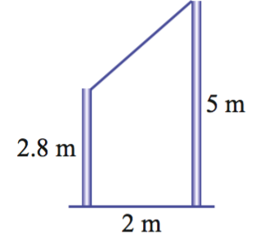
Two poles are located 2 m apart. A wire links the tops of the two poles. Find the length of the wire if the poles are 2.8 m and 5 m in height. Give your answer correct to one decimal place.

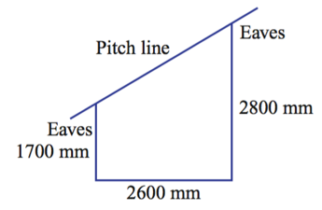
A garage is to be built with a skillion roof (a roof with a single slope). The measurements are given in the diagram. Calculate the pitch line length, to the nearest millimetre. Allow 500 mm for each of the eaves.

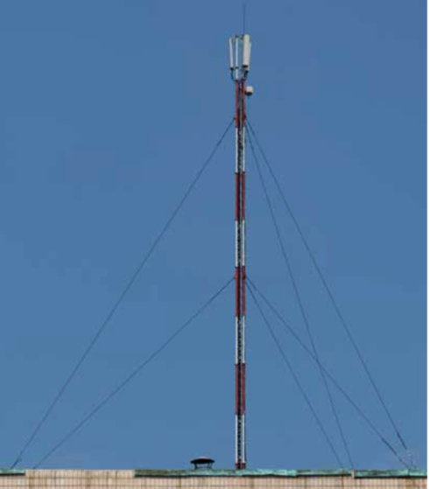
A 100 m radio mast is supported by six cables in two sets of three cables. They are anchored to the ground at an equal distance from the mast. The top set of three cables is attached at a point 20 m below the top of the mast. Each cable in the lower set of three cables is 60 m long and is attached at a height of 30 m above the ground. If all the cables have to be replaced, find the total length of cable required. Give your answer correct to two decimal places.

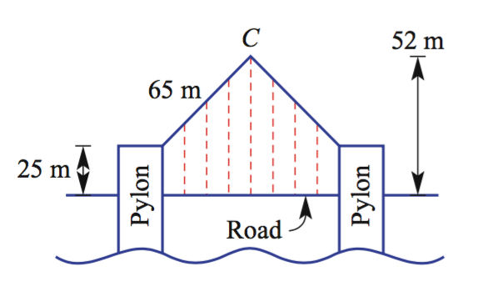
A suspension bridge is built with two vertical pylons and two straight beams of equal length that are positioned to extend from the top of the pylons to meet at a point C above the centre of the bridge, as shown in the diagram on the right.
a Calculate the vertical height of the point C above the tops of the pylons.

b Calculate the distance between the pylons, that is, the length of the span of the bridge correct to one decimal place.

A miner makes claim to a circular piece of land with a radius of 40 m from a given point, and is entitled to dig to a depth of 25 m. If the miner can dig tunnels at any angle, find the length of the longest straight tunnel that he can dig, to the nearest metre.

A bowl is in the shape of a hemisphere (half sphere) with radius 10 cm. The surface of the water in the container has a radius of 7 cm. How deep is the water? Give your answer to one decimal place.

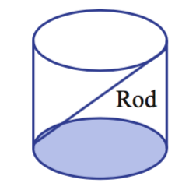
Find the length to the nearest millimetre of the longest rod that will fit inside a cylinder of the following dimensions.
a Diameter 10 cm and height 15 cm
b Radius 2.8 mm and height 4.2 mm
c Diameter 0.034 m and height 0.015 m

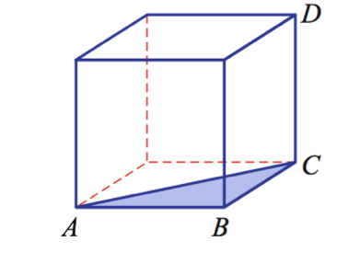
The cube in the diagram on the right has 1 cm sides.
a Find the length of AC as an exact value.
b Hence, find the length of AD correct to one decimal place.
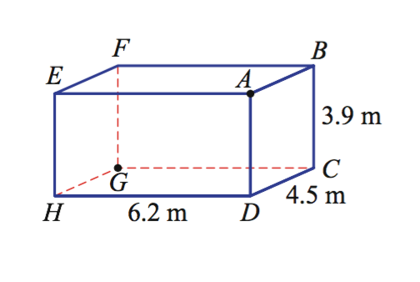
A spider crawls from one corner, A, of the ceiling of a room to the opposite corner, G, on the floor. The room is a rectangular prism with dimensions as given in the diagram on the right.
a Find how far (correct to two decimal places) the spider crawled if it crawls from A to G via:
i B
ii C
iii D
iv F

b Investigate other paths to determine the shortest distance that the spider could crawl in order to travel from point A to point G.

